**Programming Fundamentals**

**Lab Report**

**Lab 09**



|  |  |
| --- | --- |
| Group Members Name & Reg #: | **Muhammad Haris Irfan**  **(FA18-BCE-090)** |
|  |  |
| Class | Programming Fundamentals CSC103 (**BCE-2B**) |
| Instructor’s Name | Dilshad Sabir |

**In Lab Tasks**

**Question no: 1**

**Your task is to perform some functions on integer arrays. Specifically, you will write a C program**

**that does the following:**

1. Declare an array of size 20.

2. Initialize the array with random values (use loop, and rand() function).

3. Print all the elements in the array.

4. Print all the elements in the array in the reverse order.

5. Print the array such that every Nth element gets printed. N is user input.

**Solution:**

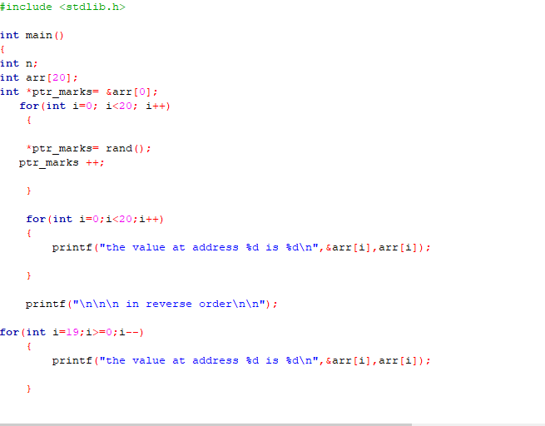

The Code for the following code is attached below,

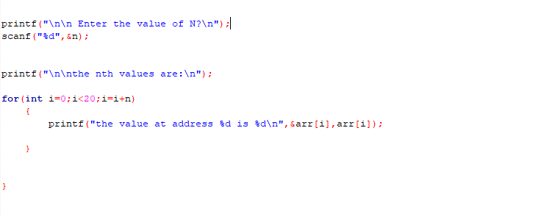

The Result of the following code is attached below:

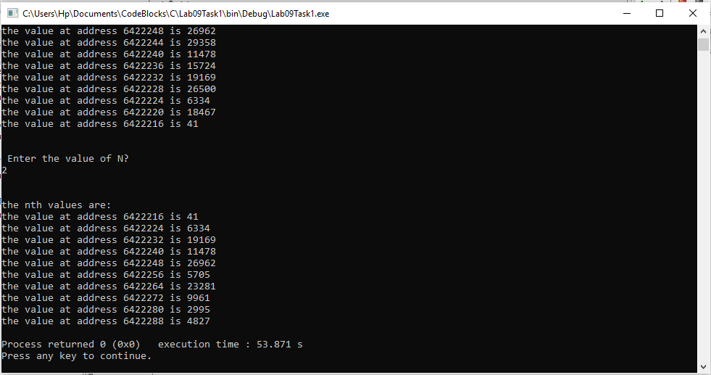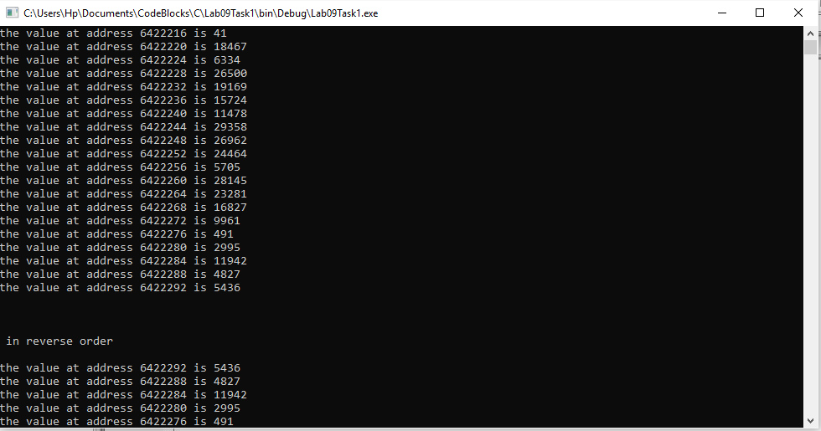

The output result verifies that our code is correct.

-------------------------------

**Question no: 2(A)**

**You are given a C program in Code Listing 1, that does the following:**

1. Declares an integer array with 50 elements (not initialized).

2. Populates the array with random positive numbers. (Uses a loop and rand() function)

3. Calls the function ‘int find_max(int * ptr_array, int size)’ and prints the

value and index of the largest number.

Solution

The code is shown below.

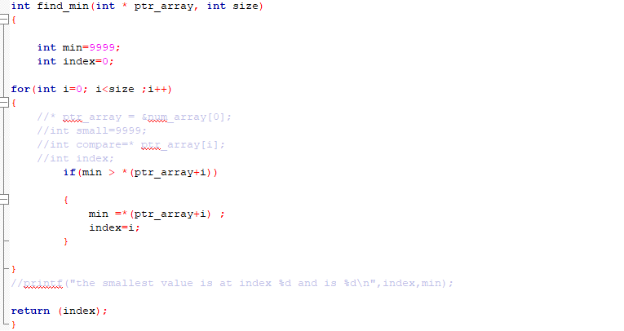

This code finds us the minimum number in the array.

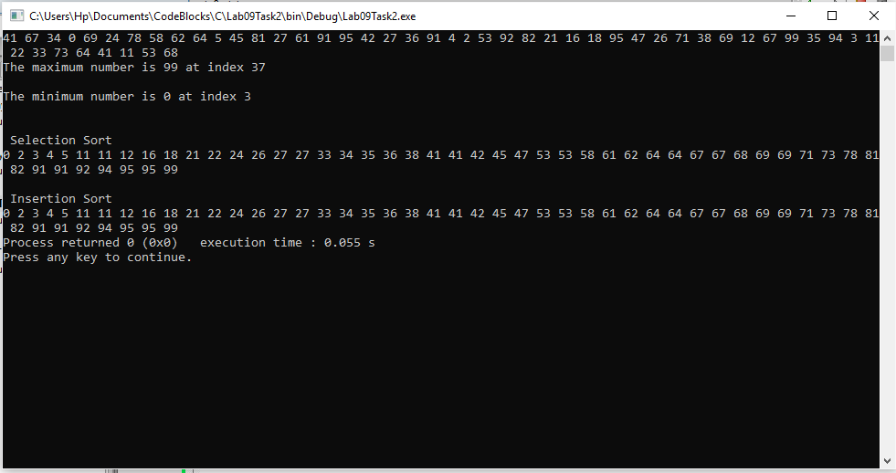

The minimum value is shown; hence our program works.

------------------------------

**Question no: 2(B)**

**Your second task is to implement the Selection Sort algorithm by making a function with the following prototype;**

*void selection_sort(int * ptr_array, int size, int order);*

This function takes as input a pointer to the start of the array, and the array size and sorts it in-place.The last input to the function is the sorting order (0 for ascending and 1 for descending). You shouldcall the functions (find_max(), find_min()) developed in lab-task 1 to implement Selection Sortalgorithm.

Solution

The code is shown below.

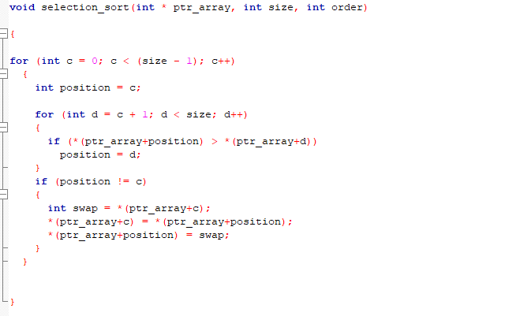

This code sorts the numbers in ascending order in the array.



hence our program works.

------------------------------

**Post Lab Task**

**Question:**

**Your second task is to implement the Insertion Sort algorithm by making a function with thefollowing prototype;**

*void insertion_sort(int * ptr_array, int size, int order);*

This function takes as input a pointer to the start of the array, and the array size and sorts it in-place. The last input to the function is the sorting order (0 for ascending and 1 for descending).

**Solution**

The code for this program is attached below,

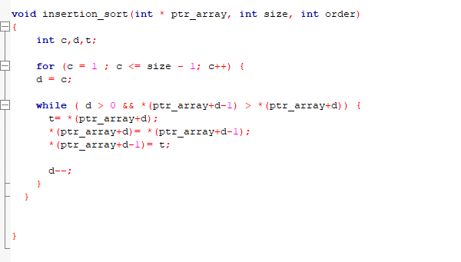

The Result of this program is attached below,



This result verifies that our code is correct as the we have sorted the array in ascending order using insertion sort.

------------------------------

THE END